Download image from freebsd.org that matches your install media and architecture. I recommend the memstick images and using a USB drive. Much faster install.

Boot to the cd/usb drive.

- Choose your keymap. If using a standard US keyboard/laptop, default is fine. There are 5 pages of variants to chose from if you wish.

- Choose a hostname for the computer. Hotstuff.mydomain.com (I always put the domain name with the hostname, if you don’t you can put it later)

- Chose the packages to install, the defaults are fine unless you want additional documentation or debug files.

- Partition your disk:

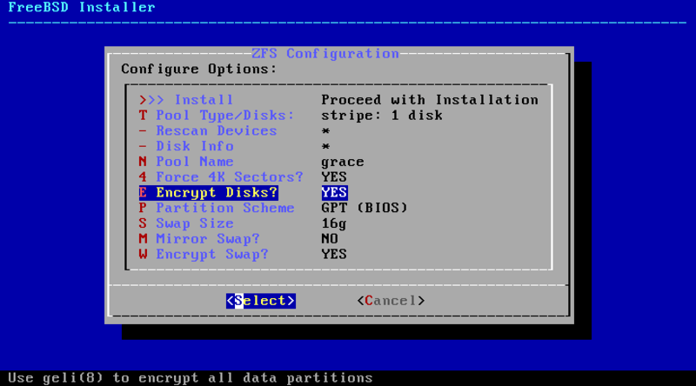

  - Choose “Auto (ZFS)” as your choice. (YES YOU WANT ZFS!!!!!)

  - on the next screen chooose pool type/disks.

  - On the next screen choose stripe ( unless you are on a desktop and want more redundancy, but I am on a laptop with one drive)

  - On the next screen use the spacebar to choose the drive you wish to install to: on mine it is ada0, my wester digital 320 gig spindle drive. Then hit enter for ok

  - If this is a laptop I would really encourage you to use the GELI encryption of your drive. It will prevent any data on your computer from being accessed. Arrow down to encrypt disks and hit enter. It will change the encryption to YES.

  - Arrow back up until you are highlighting the >>> Install line and hit enter. This will start the formatting of the disk. It will ask you are you sure, arrow to yes and hit enter again.

  - NOW it asks you for a passphrase. Choose something like a weird sentence that only you will know like “my son eats 3 boogers and licks 2 snakes! It will make you repeat the sentence again to confirm. If you forget it there is NO way to recover, so make sure you know your phrase.

  - Now the install will install the packages, so sit and wait and watch the little cursor spin.

- Next enter a password for the root account. On FreeBSD, unlike ubuntu and some Linux distros, there is still a root account. Make this secure and don’t lose it. You will enter it twice.

- Next it will want to set up a network connection. All hardware it sees that is supported will be listed. On mine I will choose the iwn0, which is my intel N6200 wireless adapter. Then you answer the questions to correctly configure your wireless.

- Once this is done, set the clock settings. Unless you want to run UTC on your laptop, chose no on this screen. It will then ask you for what time zone you are in. For me, I go to the US screens until I find “Mountain (most areas)” and choose it. Then confirm it is right.

- Next correct the date if it is wrong.

- Next correct the time if it is wrong.

- Next choose the services you want started at boot. I always do ntpd and never do sshd by default, especially on a laptop. I don’t want someone trying to get into my laptop on port 22.

- The next screen are some hardening options that originated from HardenedBSD. Read and make yoiur own choices if they are needed on your laptop. I usually don’t do any of them, since my laptop is only ever used by me.

- Next add a user to the system so you can log in not as root. Follow the screens and answer the questions. Make absolutely sure when it asks if you want to invite your user to other groups you type operator and wheel. Your user has to be in those groups to do much of anything.

- Now you are ready to hit Exit on the menu and reboot the machine. This will boot you to a command prompt so you can log in as root and start installing packages. Don’t forget to pull the usbdrive while booting!

Now you are booting into the installed system. Type in your encryption phrase when it boots then you should see if running through the bootup routine, and finally give you a login prompt. Now to start the process of turning a bare base system into a well oiled usable laptop with a gui!

- Once you log into the system, I always install vim as my first package. As my editor of choice, I need it installed first so I can configure the other packages as they get installed. So I run the following command:
root@freebeast:~ # pkg install vim
This will cause you to have to say yes you want the pkg system installed. Say yes, then hit y to
install vim and it’s dependencies.

- Now the first thing we sould do is to configure our language on the system. This is part of setting your locale in FreeBSD. As an english speaking american, I use UTF-8 as my locale. Edit the file /etc/login.conf to look like the following:
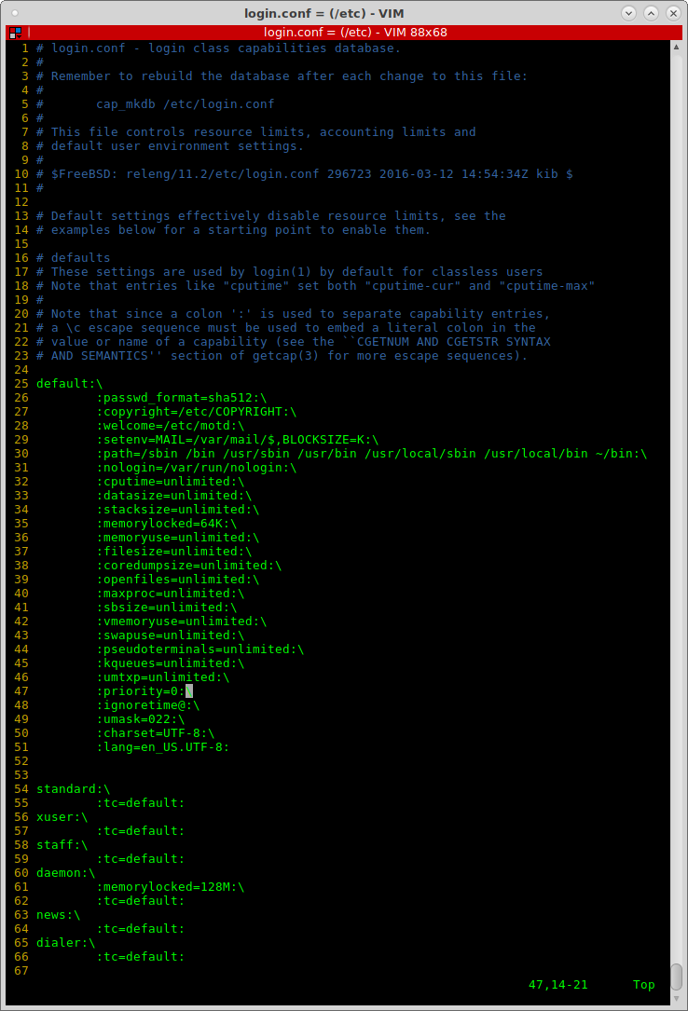

The main lines to notice is the two lines after umask=022:. Those two lines set the locale.

- Now for login managers and display managers, you also have to edit the /etc/profile and add the following two lines to the end of the file:

LANG=en_US.UTF-8; export LANG
CHARSET=UTF-8; export CHARSET

- On your next login, you can run the command locale to see that everything is set correctly to UTF-8.

- The next item we need to configure on the sytem to allow us to have a pleasant desktop experience is the tuning of the process scheduler for desktop use. Edit the /etc/sysctl.conf to look like the following:

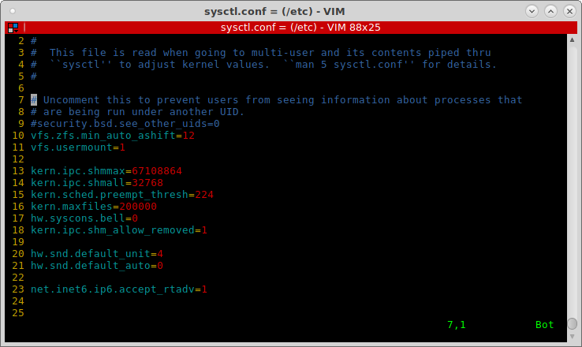
The lines you will need to add start at the kern.ipc.shmmax line.

- The next file to edit is the loader.conf file. You will turn on a lot of items in there. On the one shown below, I added every line below the zfs_load line. This will enable the very cool beastie logo at boot, turn on things like multimedia card readers, sound and linux compatibility, etc.

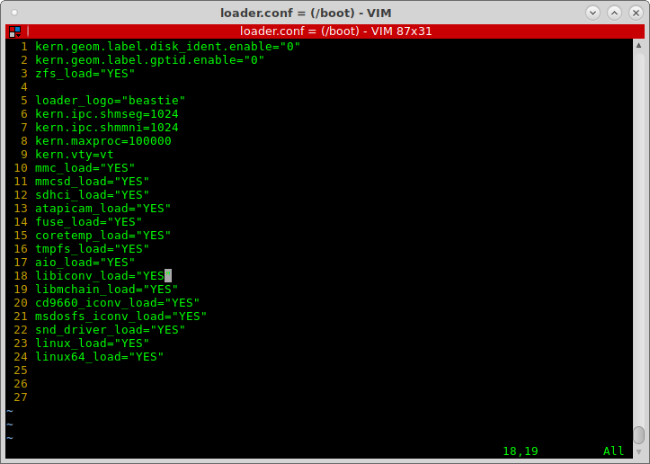

- Next we need to edit /etc/rc.conf to enable some other things.
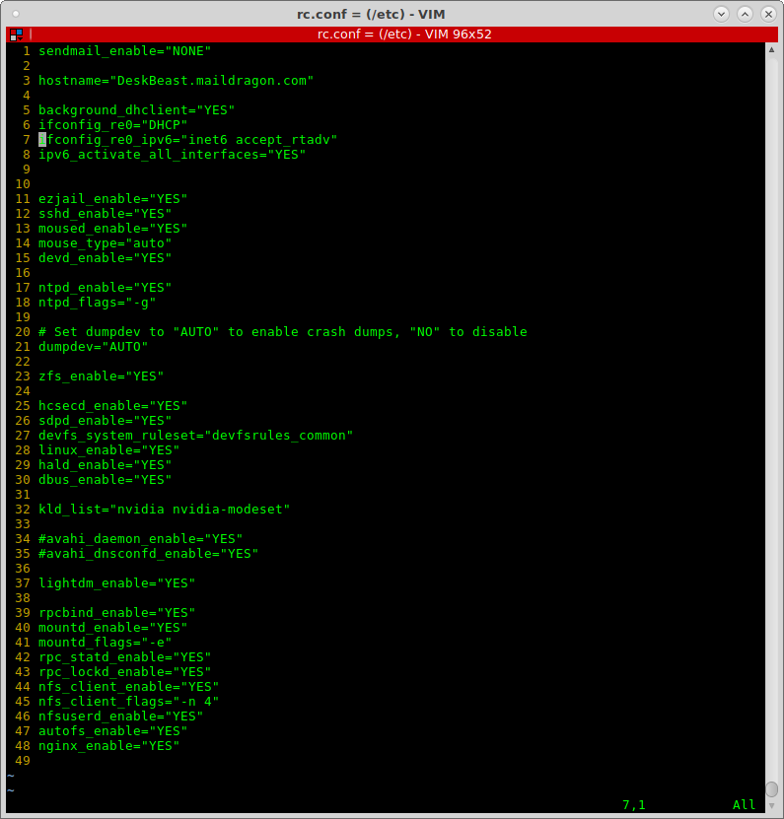

- The next item is to add some filesystems to the /etc/fstab that are needed for Linux compatability. There are some programs originally written for Linux that have been ported to BSD, like gnome, mate, etc, that need linux specific filesystems added at boot time. Add the following lines to the fstab file:

proc /proc procfs rw 0 0
fdesc /dev/fd fdescfs rw,auto,late 0 0
linproc /compat/linux/proc linprocfs rw,auto,late 0 0

These lines along with the line we added above in the sysctl.conf file vfs.usermount=1 will allow users to mount disks without having to be root.

- If for some reason your user is not a member of either the wheel or operator groups, add them at this time. To check what groups your user is in, run the following command:

id <username> (i.e. id bmccormick)

This command will list what will list the groups that user belongs to. If you need to add the user to a group, use the following command, the example is to add my username, bmccormick, to the wheel group:

pw group mod wheel -m bmccormick

- Now we need to edit the file to enable many of the different devices that you will want to use on your FreeBSD installation. The file is /etc/devfs.conf. Edit it to look like the following. Feel free to remove any devices that you will never use on your machine.

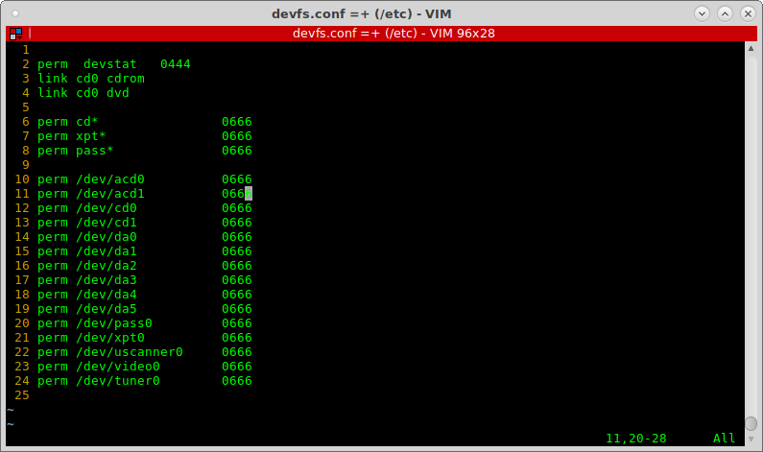

- Now that we created the devices, we need to create rules that will allow devices to be connected post-boot using the file /etc/devfs.rules:

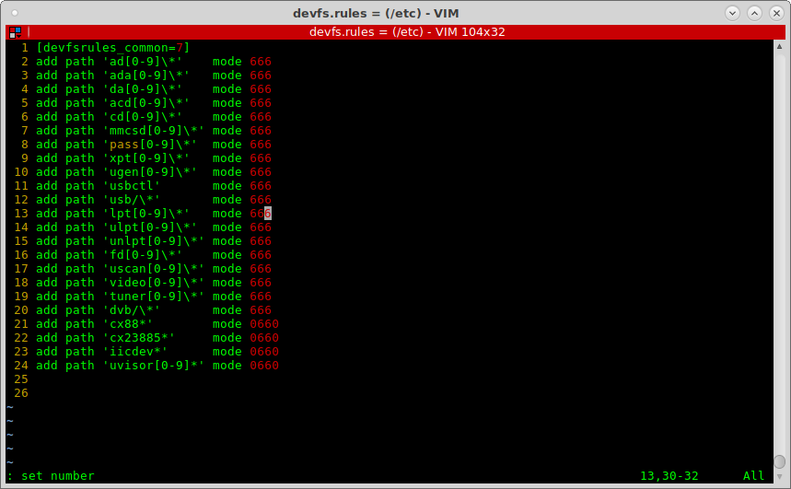

- We enabled this ruleset above in the rc.conf with the line: devfs_system_ruleset=”devfsrules_common”.

- Now in the sysctl.conf file above, we enabled a sound device. My sound device is on line 20, device number 4. Run the following command to determine the number of the sound device you want to enable:
cat /dev/sndstat
go to line 20 of your sysctl.conf and put in your device number instead of my 4.

- Networking:
  - To enable wired networking run ifconfig and determine your network devices. On my desktop, my wired network controller is named re0. On my thinkpad laptop, it is named em0. Determine your device and use it in place of the re0 on the below /etc/rc.conf configuration. The first one is for a wired network with dhcp and autoconfigured ipv6:

1. hostname="deskbeast.maildragon.com"
2.
3. # Enable DHCP for re0 and don't let dhclient block
4. background_dhclient="YES"
5. ifconfig_re0="DHCP"
6. ifconfig_re0_ipv6="inet6 accept_rtadv"

  - The next example is for a wired network with a static ip address for both ipv4 and ipv6:

1. hostname="emi.aloe.cooltrainer.org"
2.
3. ifconfig_re0="inet 172.16.0.40 netmask 255.240.0.0 broadcast 172.31.255.255"
4. defaultrouter="172.16.0.1"
5.
6. ifconfig_re0_ipv6="inet6 2001:370:10f5:806::40 prefixlen 64"
7. ipv6_defaultrouter="2001:370:10f5:806::1"

  - And the 3rd example is how to configure rc.conf for your wireless connection so it connects at boot time:

/etc/rc.conf
1. wlans_run0="wlan0"
2. ifconfig_wlan0="ssid HomeFront WPA DHCP"
The second portion of wireless is to set up the file wpa_supplicant.conf in the /etc directory so the wireless connection knows what the password is for the various networks you attach to. Here is an example:
/etc/wpa_supplicant.conf
network={
ssid="HomeFront"
psk="MySillyPasswordYouCantGuess!"
}
network={
ssid="WorkFront"
psk="TheirSillyPasswordYouCantGuess!"
}
  - Packages or Ports, that is the question!!! In the not so distant past using ports was the way to go, and you never mixed ports and packages. Those days have long gone away, and now the packages are rebuilt very frequently, so the best and recommended way to install software is using the prebuilt packages. If there isn’t a prebuilt package for something you want, then go ahead and go into the /usr/ports directory and find the port you need and build it. Before you start installing packages y ou need to make sure your packages are up to date. Run “pkg update” to make absolutely certain your list of packages is up to date.

For this how-to I am going to strictly use the packages. In step one I had you install vim using “pkg install vim”. That is the format for installing all packages, “pkg install packagename”. If you don’t know the exact packag you want, say for example you want to find all packages with the word nvidia inside the package name, use the following command: “pkg search nvidia” Below is an example of where I ran it on my desktop:

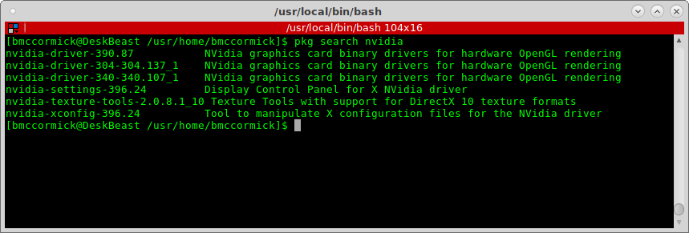

  - Going Graphical ( or how to spice up that ugly command line!!)

First we must install the X11/xorg package. This is the base xwindows server that is currently used by FreeBSD. You install it by running “pkg install xorg”. This will install 120 packages on your system to configure everything needed for a bare xserver to run, but with no frills and no fancy window managers. Just the good old Tab Window Manager in all its plain-jane glory.

  - A lot of the desktop environments still rely on some Linux specific hardware detection routines. You need to add the following two lines to the /etc/rc.conf file if they weren’t added previously:

1. hald_enable=”YES”
2. dbus_enable=”YES”

  - FONTS: you should install some additional fonts to make your programs look better. The fonts installed by default in the xorg install are not very attractive. For english users install the following fonts:

pkg install x11-fonts/anonymous-pro x11-fonts/artwiz-aleczapka x11-fonts/dejavu x11-fonts/inconsolata-ttf x11-fonts/terminus-font x11-fonts/cantarell-fonts x11-fonts/droid-fonts-ttf x11-fonts/doulos x11-fonts/ubuntu-font x11- fonts/stix-fonts

One additional font set you will want is the x11-fonts/webfonts. It includes the Microsoft Core Fonts for the Web. To install this you need to create an /etc/make.conf file with the following content before installing it:

/etc/make.conf
# Enable Tahoma in x11-fonts/webfonts if you have a Windows license
# You show me yours and I'll show you mine ;)
.if ${.CURDIR:M*/x11-fonts/webfonts}
WITH_MSWINDOWS_LICENSE=yes
.endif
Once this is done run “pkg install x11-fonts/webfonts” to install it.

  - Now we can test that your basic xorg server will run by running the command “startx”. If it give you two xterm windows, and a login window in beautiful white with green borders and an awsome non-digital clock, you have successfully installed xorg and it is runing on your machine. Now, this does not have any video specific drivers on it, but it is fully functional. Hit ctl-alt-F1 to go back to the first tty and hit ctl-C to kill the xwindow session.

  - Window Managers: now we plan on doing an entire session on some of the various Window Managers available to a BSD user. Below is a quick list of some of the more known managers, and a small snippet about them. You can search the internet and find out more about each of them and choose something that fits your style of work. Try a few of them, you can have multiple installed, and see what fits your style of work. There is NO one size fits all here!

    - Lumina – one of the only window managers written specifically for BSD. Was written by the PC-BSD/TrueOS project and is available as far as I know on all BSD variants. Similar in style to KDE without all the overhead. ** pkg install lumina

    - Mate – (one that I use a lot!) the community port of Gnome 2 which they forked the original gnome 2.0 code. Very familiar for any user that has used gnome, kde, windows of any version, etc.
** pkg install mate

    - WindowMaker – minimalistic manager based on the NEXTSTEP O/S look and feel. It allows you to have docks with applications in it. Very low resources, and very configurable. This is one I am using more and more these days.
** pkg install windowmaker

    - OpenBox – very light weight, highly configurable. One that I am learning how to configure and use. The more I use it the better I like it.
** pkg install windowmaker

    - KDE – has every function in a desktop you have ever imagined. Great if you don’t mind the resources to run it. It is not good on low resource machines. It has the largest footprint of any manager I know of.
** pkg install kde

    - Enlightenment – the original eye-candy. This was the original pretty desktop with lots of features.
** pkg install enlightenment

    - XFCE – decends from the original Solaris Common Desktop Environment (CDE). Very light weight and the later versions of this desktop will remind you of a Windows 95/98 feel and look. Very easy desktop for a first time user migrating from Windows to a *nix.
** pkg install xfce

    - Cinnamon – began as a fork of the Gnome 3 Shell to keep more traditional panels and menus. This does not have any of the Cannonical or the Gnome 3 versions of the desktop and the panels they added.
** pkg install cinnamon

    - Gnome 3 – As Allison Nicole Reid wrote this was a version of Gnome where “ the GNOME team lost their collective minds” and tried to change everything that was liked by anyone.
** pkg install gnome3

    - IceWM – very windows95-esc window manager. Very light weight.
** pkg install icewm

    - I3 – tiling window manager. NOT for beginners. This has to be configured in every single item. People who configure it and get used to it rave and love it. I personally haven’t used it enough or spent enough time using it to have a real opinion on it. (rating on slant.com of 96 - was the highest rated one)
** pkg install i3

    - Awesome WM - (rating on slant.com of 95 - was the second highest)
** pkg install awesome

    - Xmonad - (rating on slant.com of 93)
** pkg install hs-xmonad

    - dwm - (rating on slant.com of 91) – The one I am now using full time on both BSD and Linux machines. I can blame this one on Christer!
** pkg install dwm

    - Fluxbox - (rating on slant.com of 85)
** pkg install fluxbox

    - *** There are 138 different window managers in /usr/ports/x11-wm on FreeBSD and several of the larger window managers are in the /usr/ports/x11 directory with their own various parts there. So there is somewhere around 150 window managers available for your viewing pleasure.

  - Display managers – several window managers have their ports’ specific display manager in them. Gnome and gnome based ones have GDM, KDE has KDM, xdm has a version on FreeBSD, there is a lightdm, and there is slim. I suggest you either use lightdm or slim. Both will work fine, just depends on what you want. Slim is a non-wm specific choice that is highly configurable.

  - For my install I am going to install dwm, Mate, Windowmaker, OpenBox and the slim dm. I run the following command:

pkg install dwm windowmaker mate openbox slim slim-freebsd-themes slim-freebsd-black-theme slim-themes

  - Printing: You should use the CUPS printing package to print from your desktop. Run the following command to install CUPS and its packages:

pkg install cups hplip foomatic-filters foomatic-db foomatic-db-engine cups-pdf

Now that those are installed you need to configure a couple of lines additionally in your rc.conf file. Add the following to the bottom of that file:

# Disable line printer daemon since we have CUPS
lpd_enable="NO"
# Enable CUPS
cupsd_enable="YES"
The last part of printing is adding your normal user and root to the cups group so you can print. Run the following:

pw group mod cups -m bmccormick
pw group mod cups -m root

Once you reboot you should be able to get to the web configuration of cups at http://localhost:631/ in a browser.

  - Enable S.M.R.T. - run “pkg install smartmontools” to install both smartd and smartctl used to monitor the status of your local disks in your computer. Then run the following 3 commands to configure and start the services.

cp /usr/local/etc/smartd.conf.sample /usr/local/etc/smartd.conf
echo 'smartd_enable="YES"' >> /etc/rc.conf
service smartd start
  - Webcams – most usb cameras and cameras built into your laptop are supported by the webcamd driver, and depends on the cuse4bsd-kmod module. Install them both by running:

pkg install webcamd cuse4bsd-kmod cheese pwcview

Once this is done add the following line to your /etc/rc.conf file:

webcamd_enable=”YES”

Add the following line to your /boot/loader.conf file:

cuse4bsd_load=”YES”

Then run the following command to allow your normal user to access the camera:

pw group mod webcamd -m bmccormick

  - Install Java – you need to install java for many applications. Run “pkg install openjdk8” to install Java version 1.8 to your system.

  - If you have an nvidia video card determine which version of the nvidia driver is needed for your card. I need the 304 version of the driver, so I run the following command:

pkg install nvidia-driver-304 nvidia-settings

Then you must enable the driver in your /boot/loader.conf by adding the following line:

nvidia_load=”YES”

  - Install the best terminal for *nix out there with “pkg install terminator”

  - Install a password manager with “pkg install keepass”

  - Install firefox with “pkg install firefox”

  - Install libreoffice with “pkg install libreoffice”

  - Install Sublime programming editor with “pkg install linux-sublime3”

  - To rip CDs to flac or mps install grip with “pkg install grip”

  - Install Conky to have a desktop system status package with “pkg install conky”

  - Install vlc for playing media with “pkg install vlc”

  - Install Rythmbox music player with “pkg install rythmbox”

  - Install cd burning application with “pkg install xfburn”

  - Install audio editing software with “pkg install audacity”

  - Install evolution mail client with “pkg install evolution”

  - Install an irc client with “pkg install hexchat”

  - Install pidgin instant messaging with “pkg install pidgin”

  - Install a torrent client with “pkg install deluge”

  - Install needed admin tools with “pkg install sudo doas”

  - Further Tuning – speed up boot times by modifying the following files with the corresponding lines:
    - /boot/loader.conf
boot_mute=YES

